**Seminar #2 Report**

EE810 Nie Yongxin 2186113564

#### Topic 1

# Topic 1

This topic consists of three parts, which are both regarding phase-shifting angle *φ*. For these three parts, we carried out simulations with Simulink.

# Simulation Model

In this part, the simulation is regarding series connection of 2 single-phase VSIs with single-phase full bridge inverter, and the simulation is based on the circuit diagram shown below.

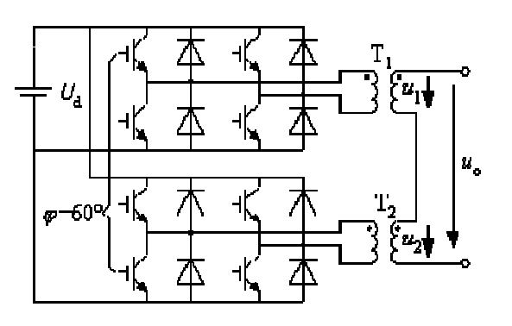

Fig. 1-1 Series connection of 2 single-phase VSIs with single-phase full bridge inverter

We used the model to carry out simulation and then we are required to change the external phase-shifting angle between inverters to observe characteristics about the circuit.

## *2.1 Circuit diagram*

## 

Fig. 1-2 Simulation model

## *2.2 Task 1*

### 2.2.1 Task requirement

Observe the single inverter’s time sequence waveform and input/output voltage relationships.

### 2.2.2 Time sequence waveform

When we set , for the full-bridge inverter, four IGBTs are conducted by for triggering pulses respectively. The pulse trigger waveforms of to are shown below.

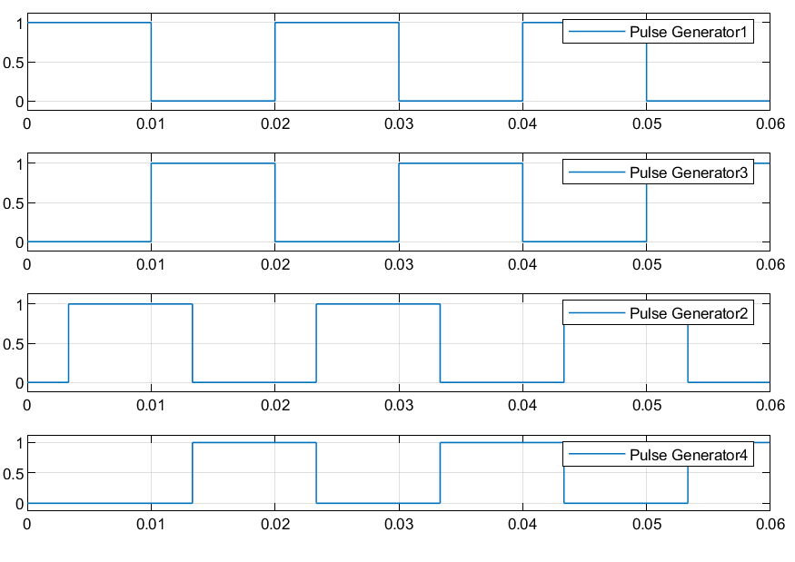

Fig. 1-3 Pulse trigger waveforms of V1 to V4

By visual inspection, we can get the four switches are conducted in turn and the sequence is →→→. (In the simulation, power diode and IGBT are in the same block, so when either diode or IGBT is conducting, the switch will be at on state.)

### 2.2.3 Input/output voltage relationship

Firstly, we set , and the waveforms of input and output are shown in fig. 1-4.

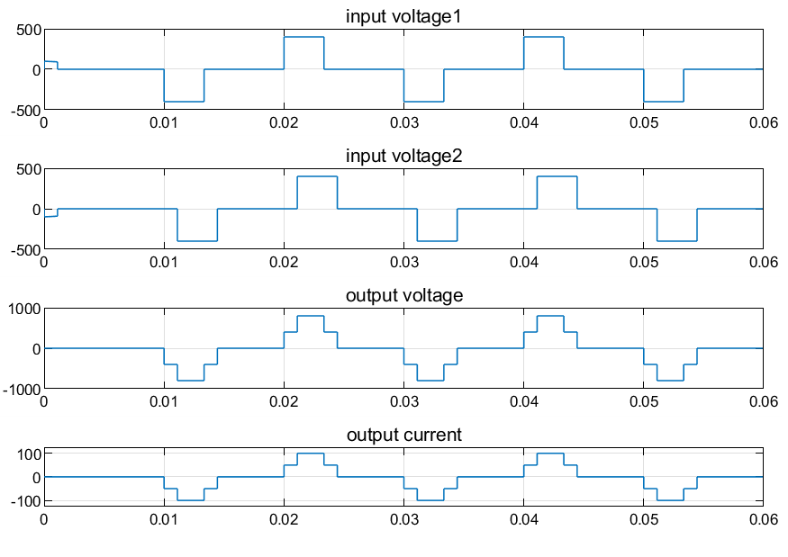

Figure 1-4 input voltage signal and output voltage and current signal

Then, we set , and the waveforms of input and output are shown in fig. 1-5.

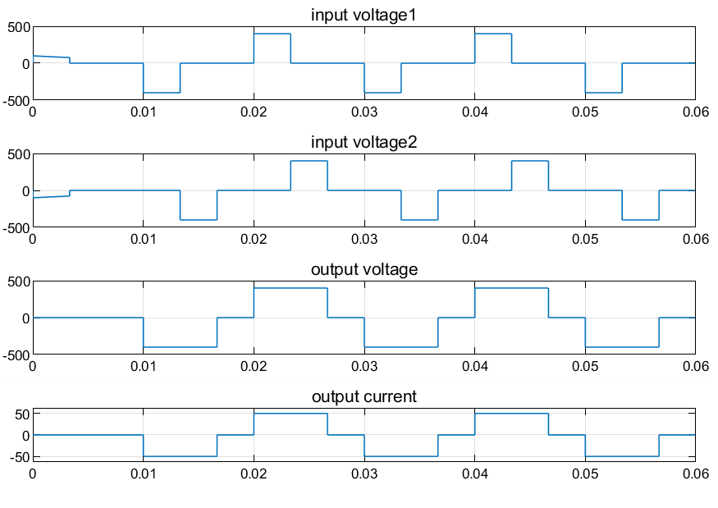

Figure 1-5 input voltage signal and output voltage and current signal

From the figure, we can discover for the 2 single-phase VSIs, the output voltage of inverter equals to the superposition of output voltage of each single-phase VSI.

## *2.3 Task 2*

### 2.3.1 Task requirement

Study the basic operating principle of series connection of multiple single-phase VSIs.

### 2.3.2 Operating principle

Series connection of multiple single-phase VSIs consists of two single-phase full-bridge inverters and they are connected by transformer T1 and T2. From Task1, we have already known that the output voltage of inverter equals to the superposition of output voltage of each single-phase VSI. Besides, we can change the output waveform by changing the external phase-shifting angle *φ*.

In figure 1-5 to 1-7, we get the input and output waveform when φ equals to 20°,60°,80° respectively.



Figure 1-5 input voltage signal and output voltage and current signal



Figure 1-6 input voltage signal and output voltage and current signal

In our circuit , so the first critical angle is . When external phase-shifting angle is within the interval of , the proportion of zero part in output voltage is decreasing, i.e. the duty cycle is increasing.

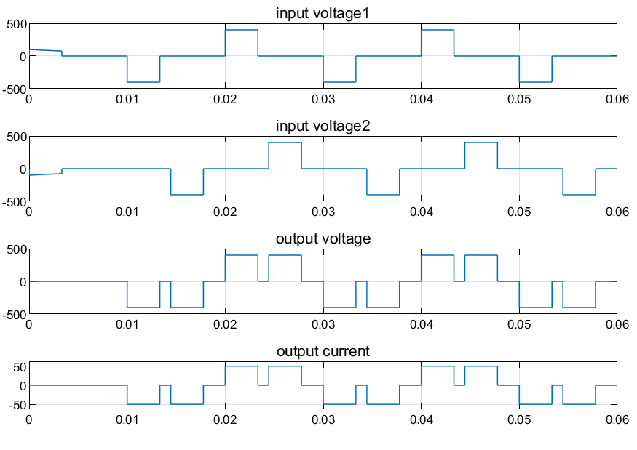

Figure 1-6 input voltage signal and output voltage and current signal

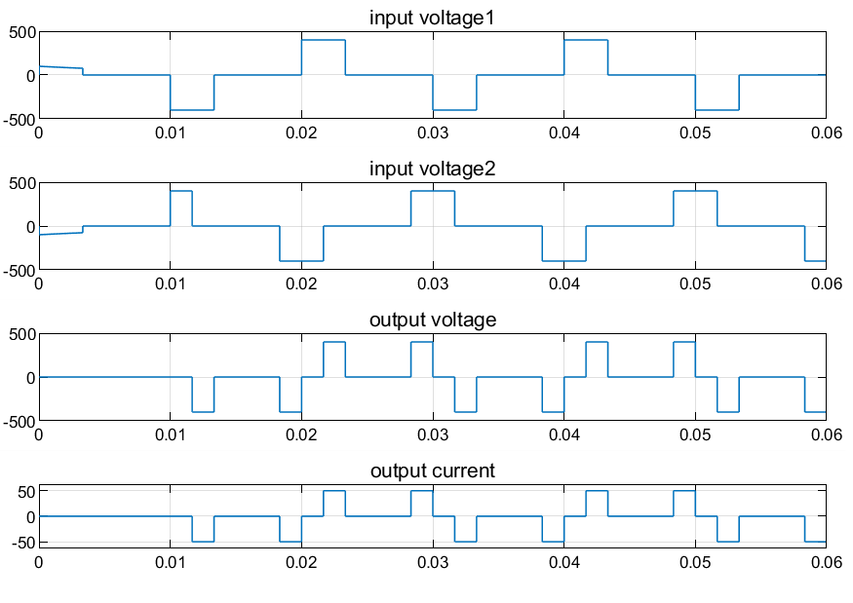

Figure 1-7 input voltage signal and output voltage and current signal

If , we can see the output voltage is constant zero.

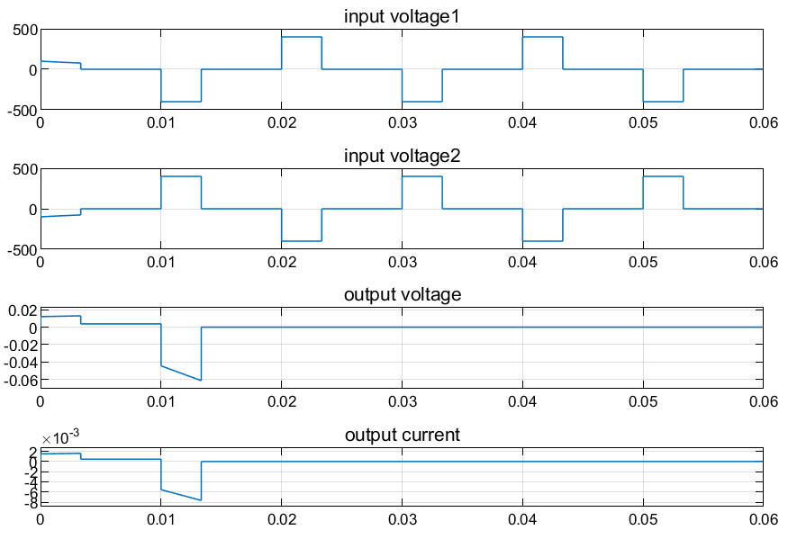

Figure 1-8 input voltage signal and output voltage and current signal

When external phase-shifting angle is within the interval of , the proportion of zero part in output voltage is increasing, i.e. the duty cycle is decreasing. In this part, we get the second critical angle . When , with increases, the shape of output voltage changes little. We can get in Fig. 1-6 to 1-8, is the critical angle of shape change of waveform.

And, during the interval of , the regularity of output is symmetrical to the interval of .

Then, we do harmonic analysis. From the one period waveform of in Fig. 1-7, we can get the Fourier coefficient of .

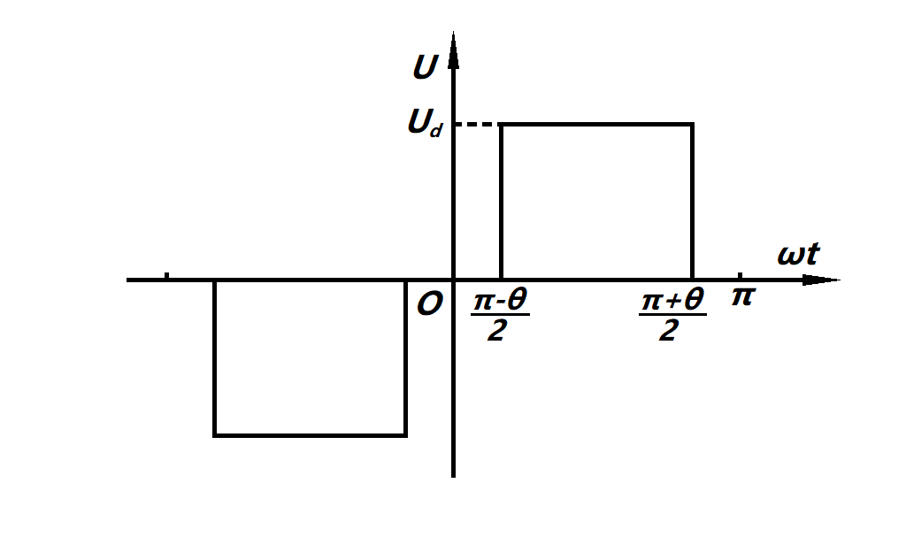

Fig. 1-7 One period of

Therefore, we can get the Fourier series of and as below.

Then, we can get .

Due to , there is no even harmonics in the output.

For instance, we set , and we will get the *Fourier* series of output as below.

+

only has harmonic components while harmonic components are all counteracted.

As for the third harmonic component of and , when we set the external phase-shifting angle , the phase deviation of third harmonic component is . Therefore, through the series connection of two transformers, the third harmonic components of and are counteracted and doesn’t have the third harmonic component. Similarly, harmonic components are all counteracted.

So, if we combine some output of inverters as definite phase deviation and make some main harmonic components of them counteracted, we can get the waveform which is very close to sine wave.

## *2.3 Task 3*

### 2.3.1 Task requirement

Plot the curves characterizing the relationships between external phase-shifting angle φ and:

1. RMS value of the fundamental component in output voltage;
2. output voltage THD;
3. 3rd 5th 6th 7th and 9th harmonics components.

By using scripting language which is shown in appendix, we change φ from 0° to 180° and then get the curves.

### 2.3.2 Matlab Program

1.数据获取

result = zeros(1,36);

result1 = zeros(1,36);

result2 = zeros(1,36);

result3 = zeros(1,36);

result4 = zeros(1,36);

result5 = zeros(1,36);

result_THD = zeros(1,36);

result_udrms = zeros(1,36);

for i = 1:1:36

fai = i*10;

sim('seminar3_1')

result(i) = simout.Data(length(simout.Data)-1);

result1(i) = simout1.Data(length(simout1.Data)-1);

result2(i) = simout2.Data(length(simout2.Data)-1);

result3(i) = simout3.Data(length(simout3.Data)-1);

result4(i) = simout4.Data(length(simout4.Data)-1);

result5(i) = simout5.Data(length(simout5.Data)-1);

result_THD(i) = simout_THD.Data(length(simout_THD.Data)-1);

result_udrms(i) = simout_udrms.Data(length(simout_udrms.Data)-1);

end

save DATA1 result result1 result2 result3 result4 result5 result_THD result_udrms

2.图像绘制主程序

clc;

clear;

close all;

load DATA1

angle = 10:10:360;

rms1 = result;

rms3 = result1;

rms5 = result2;

rms6 = result3

rms7 = result4;

rms9 = result5;

thd = result_THD;

[fitresult, gof] = createFit1(angle, rms1);

[fitresult, gof] = createFit2(angle, thd);

figure(4)

subplot(2,2,1);

[fitresult, gof] = createFit_rms3(angle, rms3);

subplot(2,2,2);

[fitresult, gof] = createFit_rms5(angle, rms5);

subplot(2,2,3);

[fitresult, gof] = createFit_rms7(angle, rms7);

subplot(2,2,4);

[fitresult, gof] = createFit_rms9(angle, rms9);

h=suptitle({'the relationships between phase-shifting angle';...

'and 3^{rd} 5^{th} 6^{th} 7^{th} and 9^{th} harmonics components'});

set(h,'FontName','Times New Roman');

figure(5)

[fitresult, gof] = createFit8(angle, rms6)

2.图像绘制函数

function [fitresult, gof] = createFit1(angle, rms1)

%CREATEFIT(ANGLE,RMS1)

% Create a fit.

%

% Data for 'untitled fit 1' fit:

% X Input : angle

% Y Output: rms1

% Output:

% fitresult : a fit object representing the fit.

% gof : structure with goodness-of fit info.

%

% 另请参阅 FIT, CFIT, SFIT.

% 由 MATLAB 于 04-Nov-2020 20:25:51 自动生成

%% Fit: 'untitled fit 1'.

[xData, yData] = prepareCurveData( angle, rms1 );

% Set up fittype and options.

ft = fittype( 'smoothingspline' );

% Fit model to data.

[fitresult, gof] = fit( xData, yData, ft );

% Plot fit with data.

figure( 'Name', 'u1' );

hold on

plot( fitresult, xData, yData );

hold off

axis([0,360,0,inf]);

xlabel('external phase angle - \phi(\circ)')

ylabel('RMS value of the fundamental component in output voltage(V)','fontname','times new roma')

title({'the relationships between phase-shifting angle';...

'and RMS value of the fundamental component in output voltage'});

legend('simulink result of RMS value','simulink result fit');

set(gca,'FontName','Times New Roman');

set(findobj('Type','line'),'LineWidth',1.5)

set(gca,'XTick',0:30:360);

grid on

(the other functions are similar to this function, they are all using the curve fit tool toolbox in MATLAB, so they are not posted here.)

# Parameter Setup

Table 1 Distributed parameters

|  |  |
| --- | --- |
| Inverter type | Single-phase full-bridge inverter |
| Internal phase-shifting angle | =60° |
|  | 400V |
|  | 8Ω |

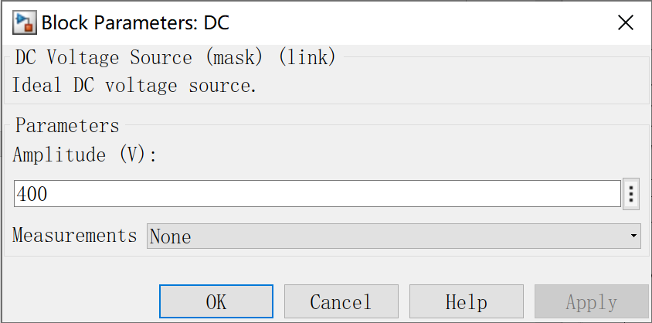

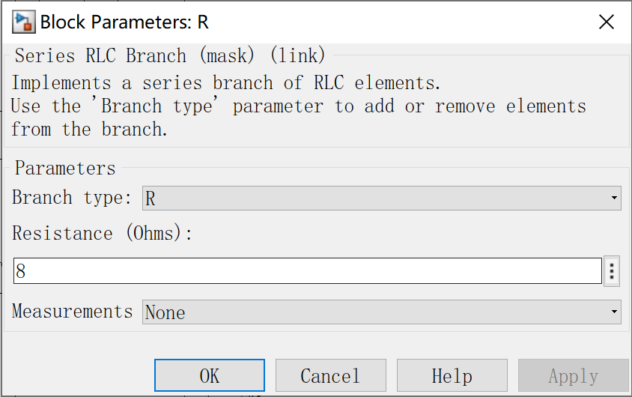

Figure 1-5 parameter setup

From the figure, we can discover for the 2 single-phase VSIs, the output voltage of inverter equals to the superposition of output voltage of each single-phase VSI.

# Analysis of the Results

### 2.3.2 Relationship between fundamental component and φ

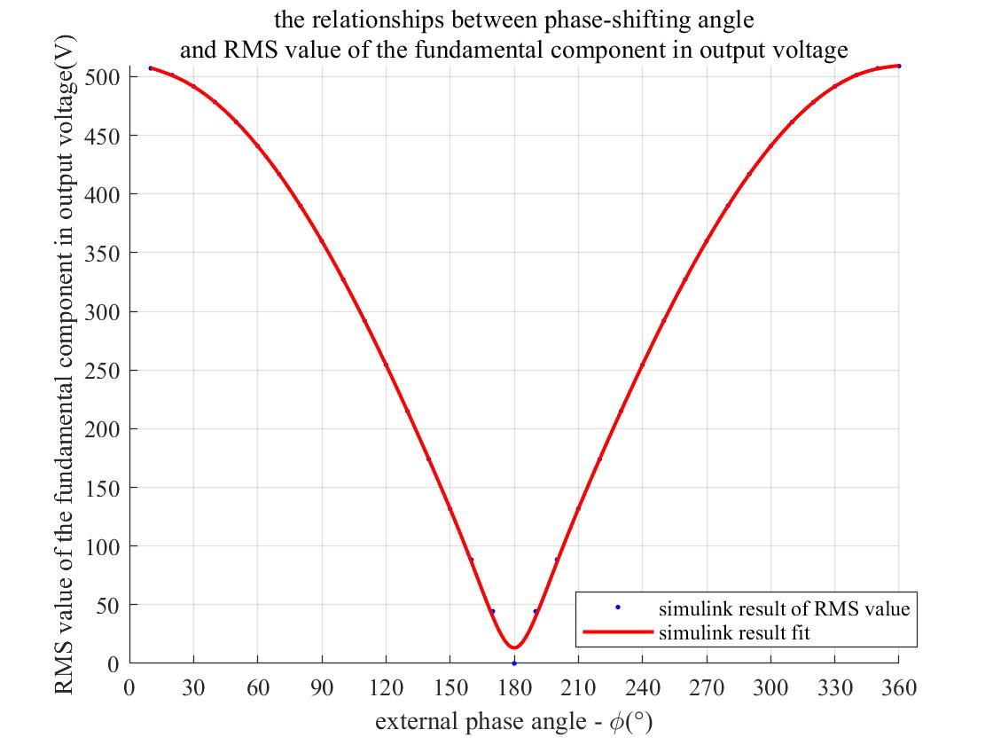

Fig. 1-15 The curve of relationship between fundamental component and *φ*

The RMS value of fundamental component in output voltage decreases with the increase of φ.

Through Fourier analysis, we can get the RMS of fundamental component in the formula as below:

We can see U1 is in direct proportion to cos *φ*/2. From the function monotonicity, we can easily get U1 decreases while φ is increasing.

### 2.3.3 Relationship between THD and *φ*

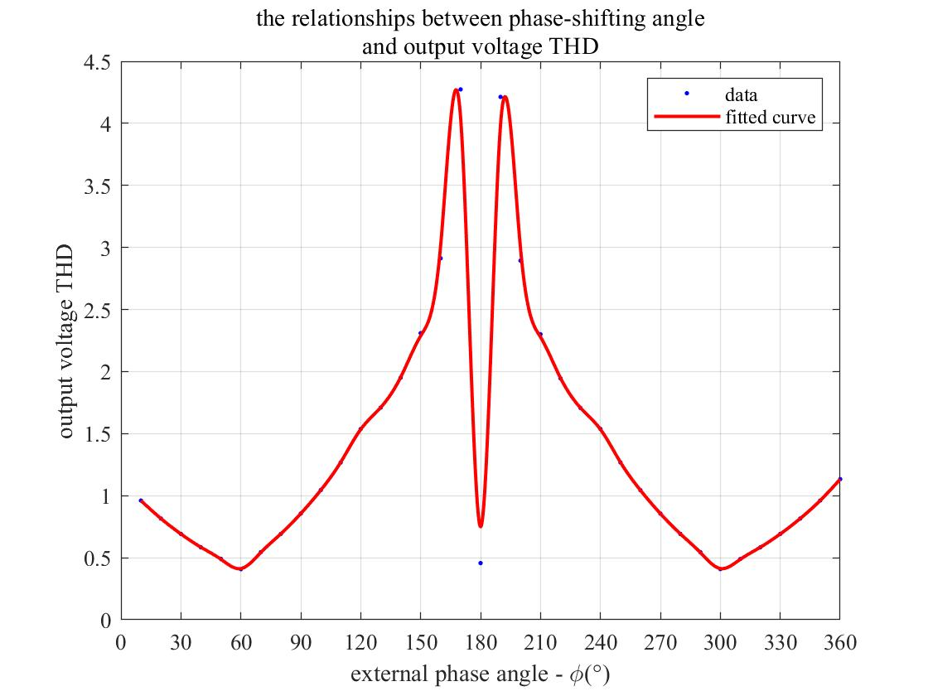

Fig. 1-16 The curve of relationship between THD and *φ*

The curve decreases during the interval from 0° to 60° and increase rapidly beyond 60° . The reason is that beyond 60° , there is shape change in voltage waveform. Besides, when φ equals to 180° , the output is constant zero, so THD is non-existent. In the simulation curve, we can see THD is about 0.5 when φ equals to 180° .

And when φ=60°, the curve gets its minimum value. From Fig. 1-18, 3rd harmonic is the main part in harmonics. At 60°, there is no 3rd harmonic while fundamental component is still very large. Therefore, the THD will get its minimum value.

### 2.3.4 Relationship between 3rd 5th 6th 7th and 9th harmonics components and φ

In the former discussion, we have known there is no even harmonic in the output. Therefore, we shouldn’t have got 6th harmonic component in the simulation. The figure below is the relationship between 6th harmonic component and *φ* .

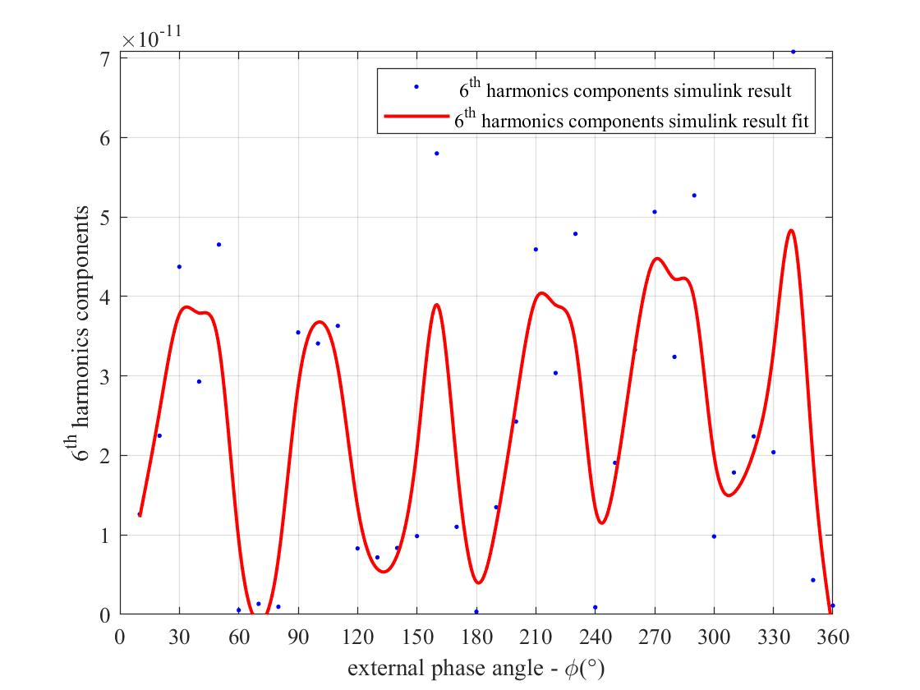

Fig. 1-17 The curve of relationship between 6th harmonic component and φ

In the simulation result, we can see the 6th is nearly zero. However, due to the algorithm of Simulink, there is small fluctuation in the figure.

We also get the curve of relationship between 3^rd,5^th,7^th and 9^th harmonic component and φ .

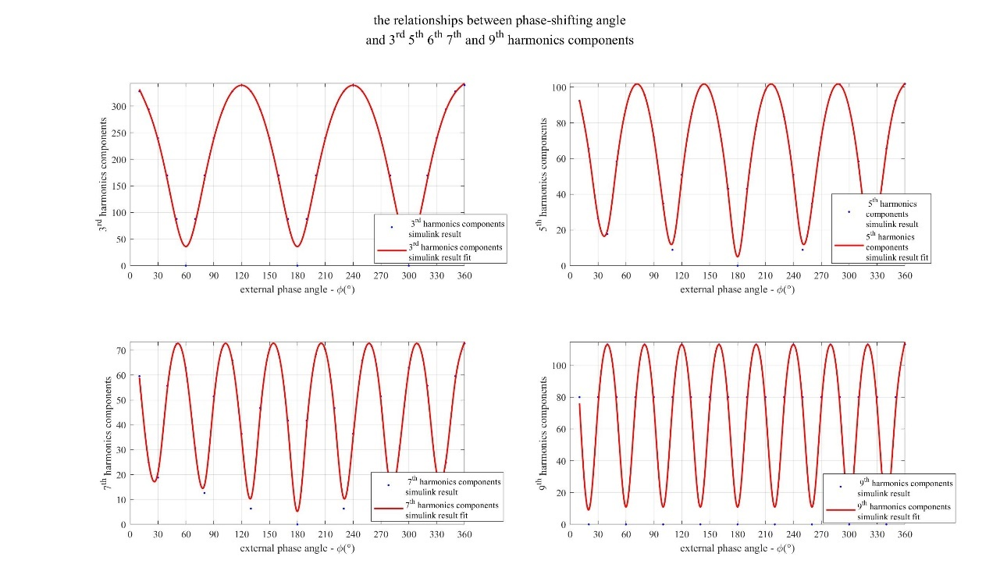

Fig. 1-18 Relationship between 3rd , 5th , 7th and 9th harmonic component and φ

By Fourier analyzation, we can get the peak value of harmonics as below.



We can see the simulation result is the same as theoretical analyzation.

#### Topic 2

# Topic 2

In this topic, the simulation is regarding three-phase bridge inverters and the simulation model is shown below.

# Simulation Model

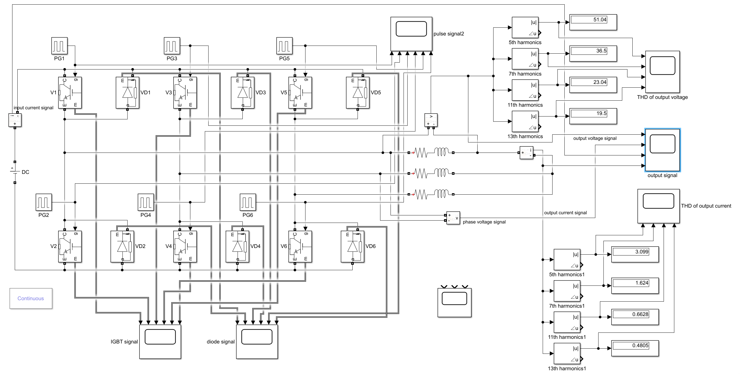

Figure 2-1 Simulation model

# Parameter Setup

Table 2 Distributed parameters

|  |  |
| --- | --- |
| Inverter type | Three-phase bridge inverter |
|  |  |
|  | 200V |
|  | 5Ω |
|  |  |

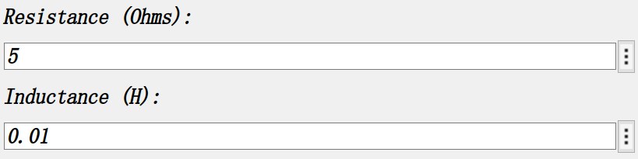

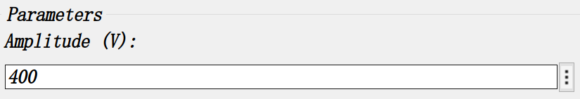

Figure 2-7 Parameter setup

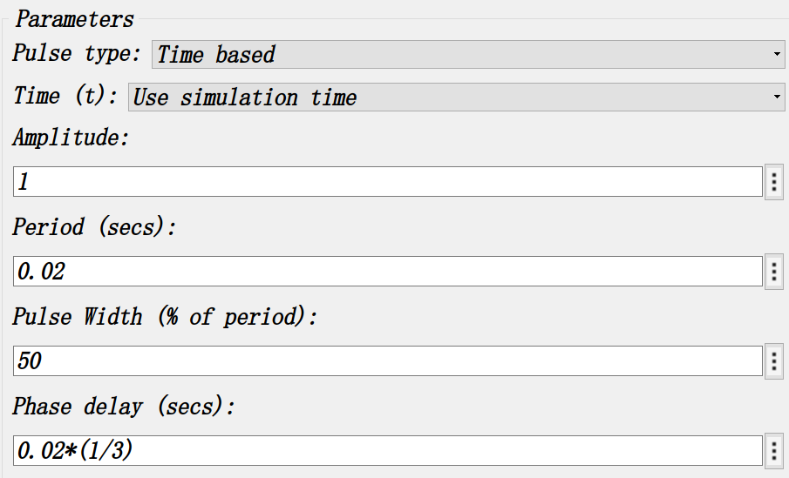

Figure 2-8 Parameter setup

# Simulation Result

### 2.2.1 Topic requirement

For three-phase bridge inverter, analyze the voltage across power switch and the current flowing through it. And calculate the 5th 7th 11th and 13th harmonics components in output voltage and output current. Then compare with simulation results.

### 2.2.2 The output voltage and current

We do the simulation and get the waveform of voltage. Firstly, the waveforms of pulse signal are shown as below.

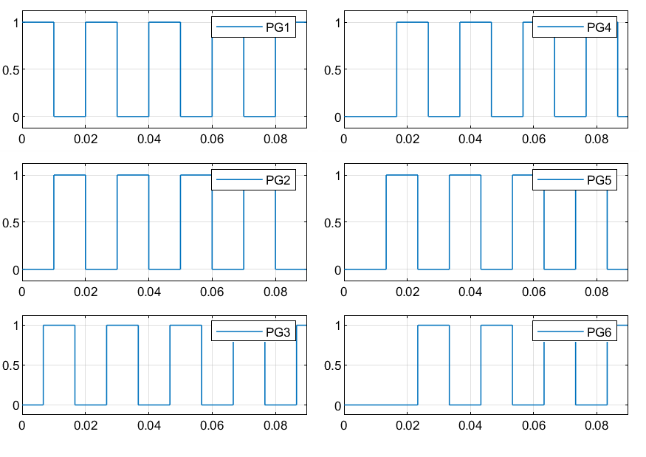

Fig. 2-2 The waveforms of and

Secondly, we get Waveform of *ud , uuv, id* and *iu*

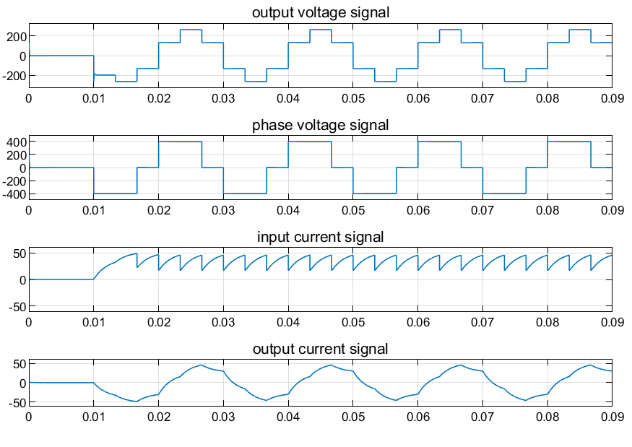

Fig. 2-4 Waveform of *ud uuv id* and *iu*

2.2.3 The voltage and current about power switch

These 6 IGBTs are triggered following the order from 1 to 6. The delay of each IGBT is . Each group of IGBTs can be divided into 3 groups (VT1 and VT4, VT3 and VT6, VT5 and VT2). There is only one IGBT of each group conducted at the same time, which means at every moment there will be 3 IGBTs conducted.

Owing to the inductance load, a small part of time of current through each bridge arm is opposite current. And during this small part of time, IGBT is not conducted, in that the free-wheeling diode is conducting current. When the current is positive, IGBT will be conducted. From the figure, we can see there is only one IGBT in this group of bridge arm is conducted during half period.

And the waveform of voltage and current about six bridge arms are shown as below.

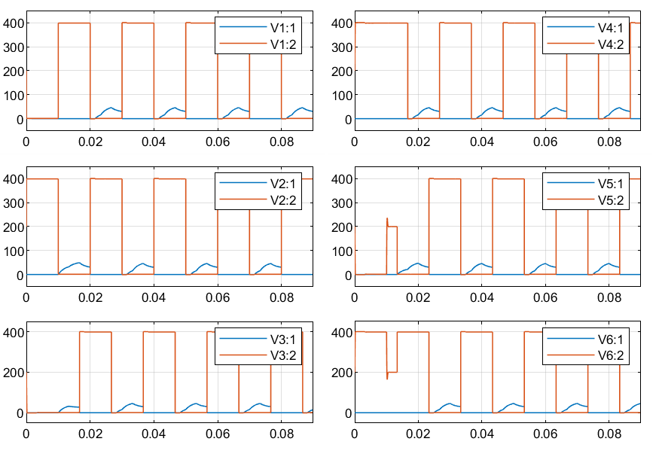

Fig. 2-6 The waveform of voltage and current about 6 IGBTs

# Analysis of the Results

To avoid the unstable state of the beginning period, we use the scope to observe the harmonics component to make sure that the measurement of harmonics component has reached the stable state.

The waveforms of the output voltage and output current harmonics are shown below.

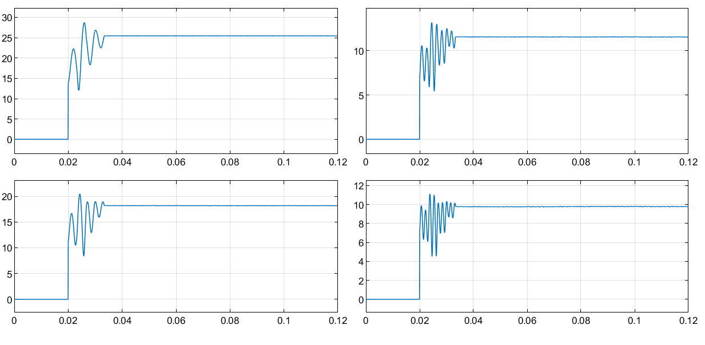

Figure 2-8 the waveform of output voltage harmonics component



Figure 2-8 the waveform of output current harmonics component

Decompose the output phase voltage to Fourier series:

+

RMS value:

From our simulation, we get 92.18V

The fundamental wave of output voltage

The simulation value is 127.3240V, and the percentage deviation is nearly 0.

The amplitude value of harmonic components are shown as below.

Table 2 Comparison of simulation value and theoretical value of harmonic components

|  |  |  |  |
| --- | --- | --- | --- |
| Harmonic number | Simulation value | Theoretical value | Percentage deviation |
| 5 | 25.45 | 25.46 | 0.03% |
| 7 | 18.17 | 18.19 | 0.11% |
| 11 | 11.55 | 11.57 | 0.17% |
| 13 | 9.77 | 9.794 | 0.25% |

Then we calculate HRVn and compare the simulation value and theoretical value.

Table 3 Comparison of simulation value and theoretical value of HRVn

|  |  |  |
| --- | --- | --- |
| Harmonic number | Simulation value | Theoretical value |
| 5 | 19.91% | 20.00% |
| 7 | 14.32% | 14.29% |
| 11 | 9.06% | 9.09% |
| 13 | 7.69% | 7.69% |

Concluding from the table, there is no obvious difference between simulation value and theoretical value.

**2.4 Calculation of harmonic components in output current**

Decompose the output phase current to Fourier series and do the calculation.

Table 4 Comparison of simulation value and theoretical value of harmonic components

|  |  |  |  |
| --- | --- | --- | --- |
| Harmonic number | Simulation value | Theoretical value | Percentage deviation |
| 1 | 23.14 | 21.5619 | 7.31% |
| 5 | 1.675 | 1.5448 | 8.42% |
| 7 | 0.9195 | 0.9065 | 1.43% |
| 11 | 0.4028 | 0.3915 | 2.89% |
| 13 | 0.1955 | 0.1980 | 1.26% |

And we calculate HRIn and compare the simulation value and theoretical value.

Table 5 Comparison of simulation value and theoretical value of *HRIn*

|  |  |  |
| --- | --- | --- |
| Harmonic number | Simulation value | Theoretical value |
| 5 | 11.23% | 11.26% |
| 7 | 6.22% | 6.20% |
| 11 | 2.66% | 2.65% |
| 13 | 1.93% | 1.92% |

There is no obvious difference between simulation value and theoretical value.